**NAME: SALEHA RAFIQUE**

**SAP ID: 49316**

**LAB 8**

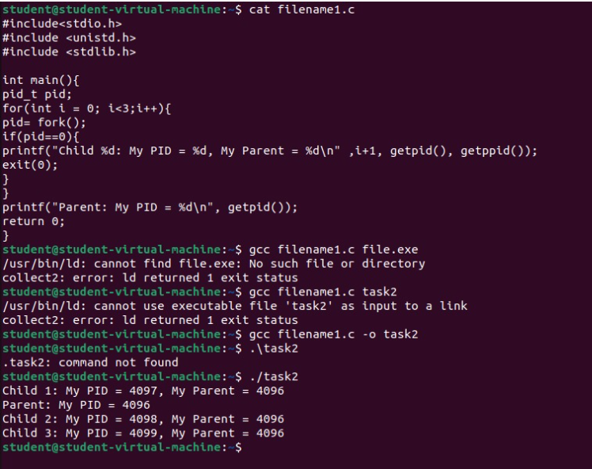

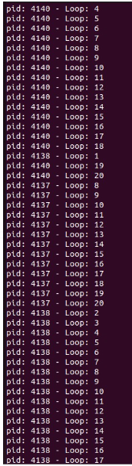

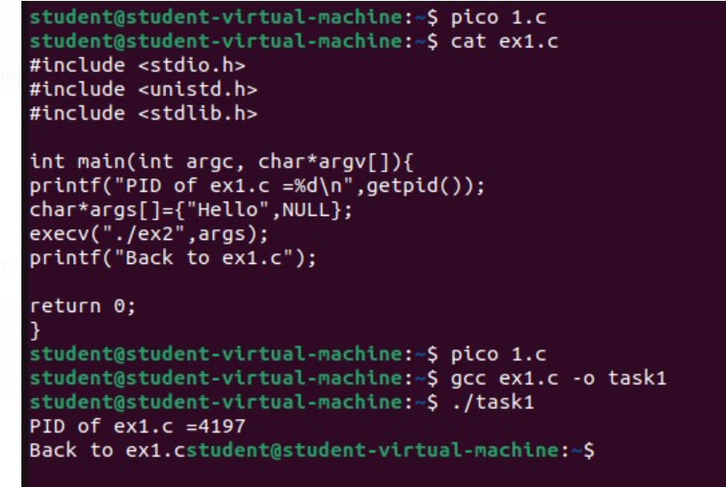

**Working of System Calls (in Short)**

System calls are the **interface** between a running program (in user mode) and the operating system's kernel (in kernel mode). When a program needs to perform a privileged operation (like accessing hardware, creating processes, or file I/O), it can't do it directly. Instead, it makes a **system call**, which is like asking the OS to do it on its behalf.

**Here's a simplified flow:**

1. **Program Request:** The user program initiates a system call. This is usually done through a library function that wraps the actual system call.
2. **Trap to Kernel:** This triggers a switch from user mode to kernel mode. The CPU transfers control to a specific location in the kernel.
3. **Kernel Handles Request:** The kernel identifies the requested system call and executes the necessary code to fulfill it. This might involve interacting with hardware or managing system resources.
4. **Return to User:** Once the kernel completes the operation, it returns control back to the user program, along with any results or status codes. The CPU switches back to user mode.

**Types of System Calls (with Examples)**

System calls are broadly categorized based on the services they provide:

1. **Process Control:** Manage the lifecycle of processes.
   * **Examples:** fork() (create a new process), exec() (execute a program), wait() (wait for a process to finish), exit() (terminate a process).
2. **File Management:** Perform operations on files and directories.
   * **Examples:** open() (open a file), read() (read data from a file), write() (write data to a file), close() (close a file), create() (create a new file), delete() (delete a file).
3. **Device Management:** Interact with hardware devices.
   * **Examples:** ioctl() (control device parameters), read() (read from a device), write() (write to a device), open() (access a device).
4. **Information Maintenance:** Get or set system-related information.
   * **Examples:** getpid() (get process ID), time() (get current time), settime() (set system time), getuid() (get user ID).
5. **Communication:** Enable inter-process communication.
   * **Examples:** pipe() (create a pipe for communication), shmget() (allocate shared memory), send() (send a message), receive() (receive a message).